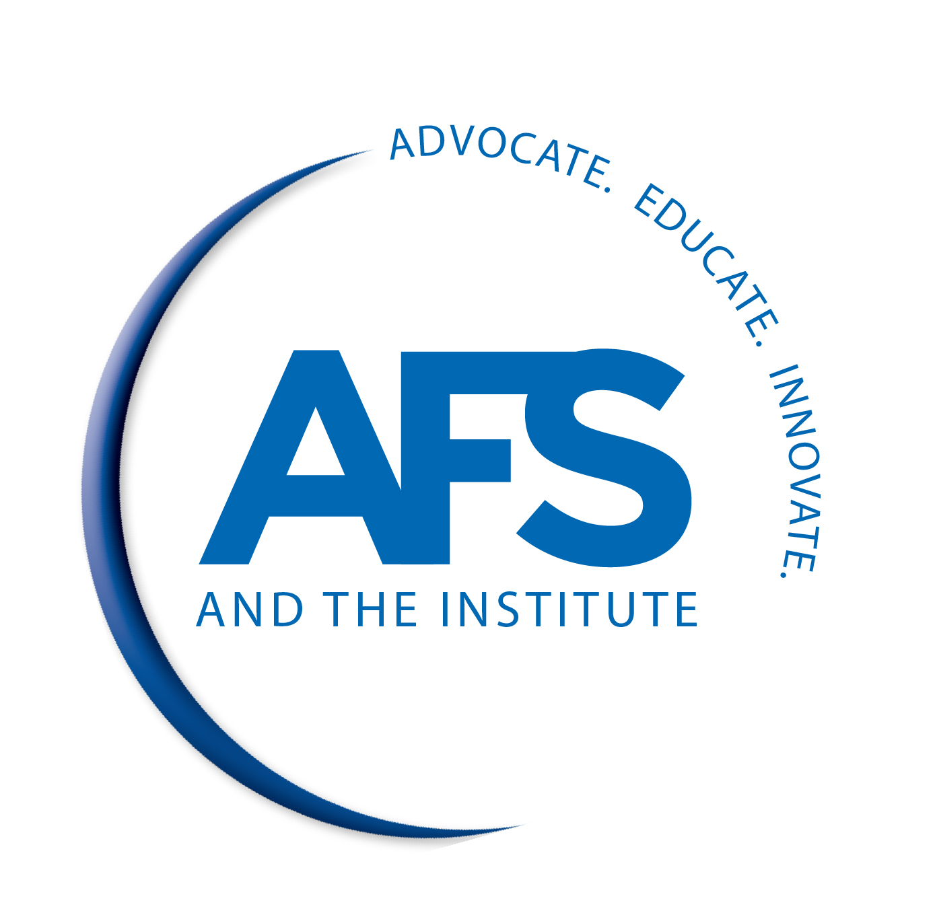

AMERICAN FOUNDRY SOCIETY
2018 GOVERNMENT AFFAIRS FLY-IN

INDIVIDUAL SPEAKER EVALUATION
Tuesday, May 15

10:10 – 10:50 a.m.
U.S. and Global Manufacturing Economic Outlook
Chad Moutray, National Association of Manufacturers 1 2 3 4 5 6

Comments ____________________________________________________________________________________
_____________________________________________________________________________________________

10:55 – 11:45 a.m.
2018 Trump Administration Trade Agenda
Vanessa Sciarra, National Foreign Trade Council 1 2 3 4 5 6

Comments ____________________________________________________________________________________
_____________________________________________________________________________________________

What “Fair” Trade is Really Doing to Our Economy
Michael Stumo, Coalition for a Prosperous America 1 2 3 4 5 6

Comments ____________________________________________________________________________________
_____________________________________________________________________________________________

11:50 a.m. – 12:30 p.m.
Planes, Trains, & Automobiles: Update on Infrastructure Legislation
Ed Mortimer, U.S. Chamber of Commerce 1 2 3 4 5 6

Comments ____________________________________________________________________________________
_____________________________________________________________________________________________

12:35 – 2:00 p.m.
Hear it First: Political Issues of the Day and the 2018 Midterms
Mike Allen, Political Journalist & Co-Founder and Executive Editor of Axios 1 2 3 4 5 6

Comments ____________________________________________________________________________________
_____________________________________________________________________________________________

RETURN TO:
Diane Waligurski, American Foundry Society
1695 N. Penny Lane, Schaumburg, IL 60173
Email: dwaligurski@afsinc.org / Fax: 847-824-7848

AMERICAN FOUNDRY SOCIETY
2018 GOVERNMENT AFFAIRS FLY-IN

INDIVIDUAL SPEAKER EVALUATION
Tuesday, May 15

2:15 – 2:55 p.m.
Update on OSHA’s Crystalline Silica Rule and Top 5 OSHA Issues Facing Foundries in 2018
Bradford T. Hammock, Jackson Lewis P.C. 1 2 3 4 5 6

Comments ____________________________________________________________________________________
_____________________________________________________________________________________________

3 – 3:30 p.m.
EPA Beyond the First Year – EPA Regulations in the Trump Era
Daisy Letendre, Environmental Protection Agency 1 2 3 4 5 6

Comments ____________________________________________________________________________________
_____________________________________________________________________________________________

3:35 – 4:05 p.m.
Critical National Labor Relations Board (NLRB) Developments & Impact on Metalcasters
Kara Maciel, Conn Maciel Carey 1 2 3 4 5 6

Comments ____________________________________________________________________________________
_____________________________________________________________________________________________

Wednesday, May 16

7:30 – 9:30 a.m.
Current Developments and Opportunities at SBA
Natalie Lui Duncan, U.S. Small Business Administration

Comments ____________________________________________________________________________________
_____________________________________________________________________________________________

RETURN TO:
Diane Waligurski, American Foundry Society
1695 N. Penny Lane, Schaumburg, IL 60173
Email: dwaligurski@afsinc.org / Fax: 847-824-7848

AMERICAN FOUNDRY SOCIETY
2018 GOVERNMENT AFFAIRS FLY-IN

EVALUATION FORM

Name ____ (optional)
Company ____ (optional)

Please rate the following criteria on a scale of 1 - 6 circling the appropriate number listed after the category:

CONFERENCE PROGRAM LOW TO HIGH COMMENTS

Program Organization 1 2 3 4 5 6 ______________________________

Program Content 1 2 3 4 5 6 ______________________________

Relevance to Your Interests 1 2 3 4 5 6 ______________________________

Speaker Presentations 1 2 3 4 5 6 ______________________________

Organization of Hill Visits 1 2 3 4 5 6 _____________________________

Location 1 2 3 4 5 6 _____________________________

Suggested topics for a similar future conference:

_______________
____________________________________________________________________________________________________
____________________________________________________________________________________________________

General comments:
_______________
____________________________________________________________________________________________________
____________________________________________________________________________________________________
____________________________________________________________________________________________________

RETURN TO:
Diane Waligurski, American Foundry Society
1695 N. Penny Lane, Schaumburg, IL 60173
Email: dwaligurski@afsinc.org / Fax: 847-824-7848

