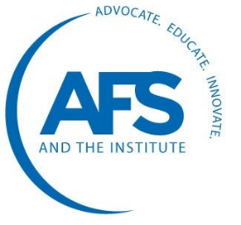
Award Criteria & Nomination Form
Ray H. Witt Award

About this Award: Ray Witt (1921-2011) was an influential metalcaster and past AFS president who founded Ray H. Witt Industries and Cast Metal Industries (later CMI International) in the mid-20th century. Witt's importance to the metalcasting industry is evident in the many institutions and honors that bear his name, including Case Western Reserve's Witt Metallurgical Modeling and Research Laboratory, Worcester Polytechnic Institute's Ray H. Witt Metalcasting Center, and the AFS Ray Witt Award.

The AFS Ray Witt Award was established to recognize work related to marketing cast metal components and management of metalcasting facilities. The intent is to recognize work that is likely to result in both immediate and lasting benefits for the cast metals industry.

Marketing: The award is designed to honor work that is aimed at increasing the size of the metalcasting industry and help insure long-term profitability and sustainability of metalcasting manufacturing. New developments and innovations that have the potential to transform the market for metalcastings include casting design innovations, development of new markets for castings, conversions to castings from other processes and developments that remove barriers inhibiting casting applications.
Management: The award is also intended to honor management-related presentations that have the potential for information, ideas, knowledge, processes or technologies to have a positive impact on the metalcasting industry, supplier or customer communities to move the industry toward higher levels of efficiency. In this area, presentations on plant management, human resources, finance, safety and other management issues are eligible.

NOMINATIONS
- The chair of each AFS Division may nominate one candidate paper each year for the Ray H. Witt Award.
- Nomination criteria:
  - Presentations that were included in the education program organized by the nominating division as part of the annual AFS Metalcasting Congress.
  - The work has been published in an AFS venue; i.e. AFS Transactions, Modern Casting, Metalcasting Design and Purchasing, International Journal of Metalcasting, etc.
- The Division Best Paper Award selection and the Ray Witt Management Award are to be considered as completely separate functions from the Howard Taylor Award and need not necessarily involve the same paper.
- A standard nominating form will be used to submit nominations. This form is to be returned to the Honorary Lectures & Paper Committee Chair in care of the AFS Vice-President of Metalcasting Technical Services and/or AFS Senior Technical Coordinator.
- Papers must be nominated in essay form in response to the guideline questions. It is the responsibility of each division to explain the virtues of the paper nominated.
- Nominations from the divisions must be received by the deadline date as determined by the AFS staff.
- Final award selection will be made by the Honorary Lectures and Papers Committee at the Fall Technical & Management Council meeting.
SELECTION
- Evaluation and selection of Howard F. Taylor and Ray H. Witt Award nominations are a function of the Honorary Lectures & Papers Committee (HLPC). The members on the committee will consist of:
- Chair, vice-chair, secretary and secretary-elect of the Technical Council, at-large members of the Technical Council, and chair of the Management Council.
- Vice-chair of the Technical Council shall serve as chair of the HLPC. Other Technical and Management Council members may participate as auditing (non-voting) members.
- All HLPC members will be given an opportunity to review and rank nominated papers. A compilation of those rankings will be provided to HLPC for guidance in making their final selection.
- The HLPC committee will set scheduled meeting dates and times to evaluate the candidate papers for selection of a winner.
- It is recommended that the Honorary Lectures & Papers Committee make an award selection each year. However, HLPC may select a nominated paper to receive the award or determine that none of the submitted nominations meet the award criteria.
- Selection will be made from the nominations of the current Metalcasting Congress year plus the previous two years. All papers from this three-year period are eligible.
- The Honorary Lectures and Papers Committee may seek additional information on any paper in contention, either from the nominating body or from any other source.
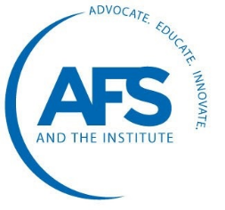
Ray H. Witt Award Nomination Form

Title:

Paper Number:

Author(s) / Company:

Nominating Division:

EVALUATION:

  - Why is this work significant to metalcasting management or marketing?

  - What impact will this work have on the fields of cast metals production, business management, profitability or casting marketing and end use?

  - What is the time span during which the work will impact the metalcasting industry; i.e. immediate, short term (2-5 years), long range? Explain.

  - Does this paper present new information or does it complete or enhance the current knowledge base? Please illustrate.

  - Does the work respond to an important need? Please illustrate.

